Assignment 1 – Practical Data Science with Python
Tommy Flasza – S4092115

Data Preparation
The Dataset provided displays the crashes, Victoria. After manually analysing the spreadsheet and identifying the most important information needed for analysing, I used the pd.read_csv() to load the crash set into the pandas Data Frame. As I’m using python it is the best way to get the csv data in and be available to be cleansed. In the entire dataset there was a total of 150,000 rows and 52 columns of data.
Incorrect Date and Time format: The ACCIDENT_DATE and ACCIDENT_TIME columns were stored as raw strings. I used parse_date() and parse_time() with try and except blocks, using this allowed for values that couldn’t be parsed to return NaN that would stop the script from crashing when being fed into the script. ACCIDENT_DATE was converted into a datetime format (DD/MM/YYYY) and ACCIDENT_TIME was converted to a time object (HH:MM:SS) which allows easier analysis and pinpointing correct date and time when put into graphs.
Missing Values:
SRNS: While checking the dataset a column named SRNS had around 70% of missing data and as there was no reliable way to fill in the missing values, I dropped the column due to if it was kept or even adding in new values to replace them could be misleading.
Dropping Rows: LATITUDE, LONGITUDE and NO_OF_VEHICLES rows had a few missing values which in perspective of the dataset shouldn’t have made an issue, so I dropped them as they are important columns for the analysis and it was minimal how much was truly lost.
Categorical Columns: some columns like ROAD_NAME, ROAD_TYPE and LGA_NAME had some of the missing values filled in with an unknown as the rows still featured data that was useful to the case finding but it was just that little gap of data. Using the unknown allowed for the data to remain in the set while also outlining there was some missing values.
Redundant Columns: The Dataset had VICGRID_X and VICGRID_Y which is the coordinate system but was seen as redundant as we have LATITUDE and LONGITUDE which gives us either more or the same geographic information but allows for other parties to find the places easier. It was mainly dropped so the dataset remained clean and universally correct. The “errors =’ignore’” line was applied just in case the columns didn’t exist.
Fixing Dirty Categories: The DAY_OF_WEEK column had some ambiguous and unique values. Thursday was spelled as ‘Thu’ in some entries and ‘Weekend’ which is ambiguous as it could’ve been a Saturday or Sunday. I fixed up these errors by mapping ‘Thu’ to be seen as ‘Thursday’ and ‘Weekend’ to be seen as ‘Saturday’ as Saturday is the first weekend day and it’s safe to assume more people would be out and about than compared to Sunday. If I didn’t fix these issues the heatmap would’ve been incorrect. LIGHT_CONDITION had ‘Unk.’ and ‘NO’ correctly mapped to ‘Unknown’ and ‘Days’ were mapped to ‘Day’ which allows it to match the category name
Cleaning SPEED_ZONE: The SPEED_ZONE column had many errors. It contained a mix of valid speeds, text inputs and values that aren’t possible. clean_speed() was a function made to handle to return NaN for missing values, entries that contained either ‘not know’ or ‘other’ and speeds that were over 110km/hr or equal to 0. Filter(str.isdigit) helped with the extraction of entries that had the km/hr instead of the integer. At the end of this it returned a valid speed and were stored in a column ‘SPEED_ZONE_NUM’ using pandas Int64 which can hold both NaN values and whole numbers whereas regular python int cannot.
Type Conversion: Vehicle count columns (NO_OF_VEHICLES, HEAVYVEHICLE, PASSENGERVEHICLE, MOTORCYCLE, PT_VEHICLE) were converted from a float to a integer as fractional counts are meaningless. ROAD_ROUTE_1 had its missing values filled with 0 before it was converted into an integer
Saving Data: The filtered data was saved to cleaned.csv using df.to_csv() with index=False to avoid writing the row numbers as a column.

Data Exploration
Q1:

The data was meant to be filtered to only 2023. ACCIDENT_TIME was reparsed with the pd.to_datetime() to allow extraction of the hour as during the cleaning process, dt.hour wasn’t used.
A heatmap was made so we can see accidents grouped DAY_OF_WEEK, HOUR and count. Days were indexed in the correct order (Monday to Sunday). Hour labels were then converted to 12-hour format so AM and PM is used to readability. The heatmap uses a YlOrRd colour scale to display how many accidents. 3PM on weekdays were the most highly dense parts of the heatmap as many people are picking up children from school while it is slightly elevated on Friday and Saturday nights.
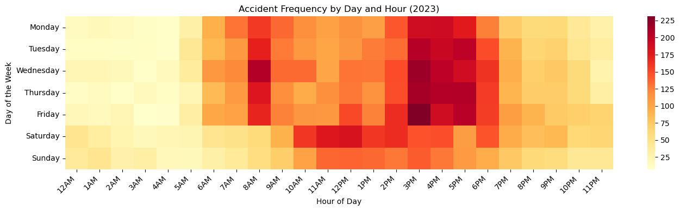

A line chart was also made to show the accidents grouped by hour and light conditions. The major finding with this chart was that daytime accidents dominate in raw numbers due to the traffic volume but dark conditions without streetlights show that there is still a risk. 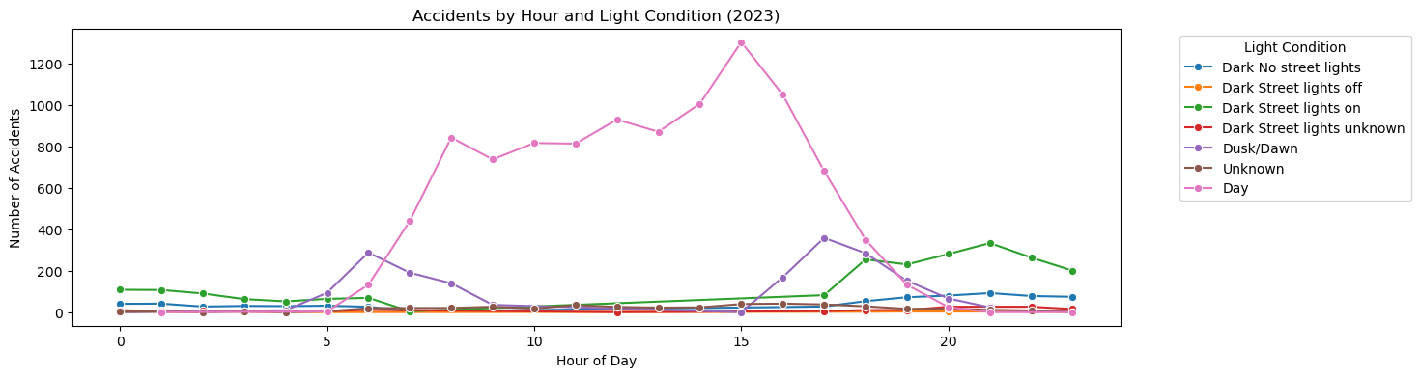
The stacked bar chart displays accidents being grouped by days of the week and light conditions while being converted into percentages. It reveals that weekends have a higher proportion of dark condition accidents when compared to weekdays. This could be due to many people being out and about on weekends and being fatigued while at the wheel. 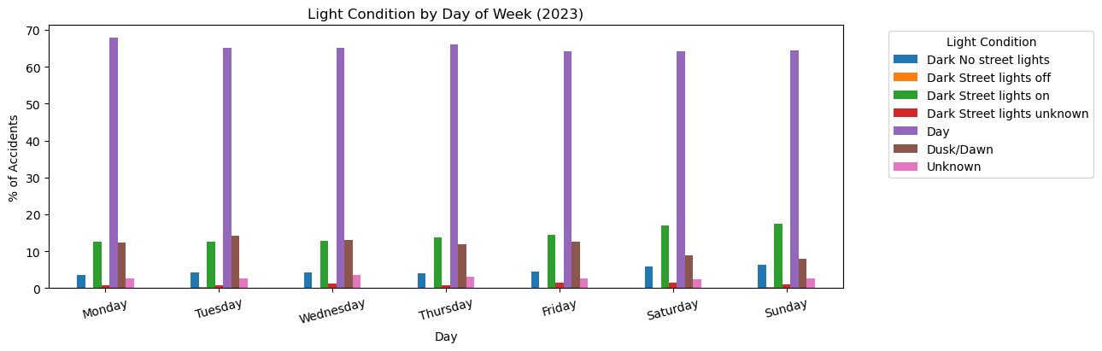

Q2:
A KDE plot was created to compare the distribution of speed zone data. Serious Injury Accident and Other injury accident were the main types that were focused on. A KDE plot was used to compare and contrast the distribution of speeds zones between the severity categories. A histogram was considered but KDE beats it as it shows the distribution as a smooth curve allowing for better analysing
. 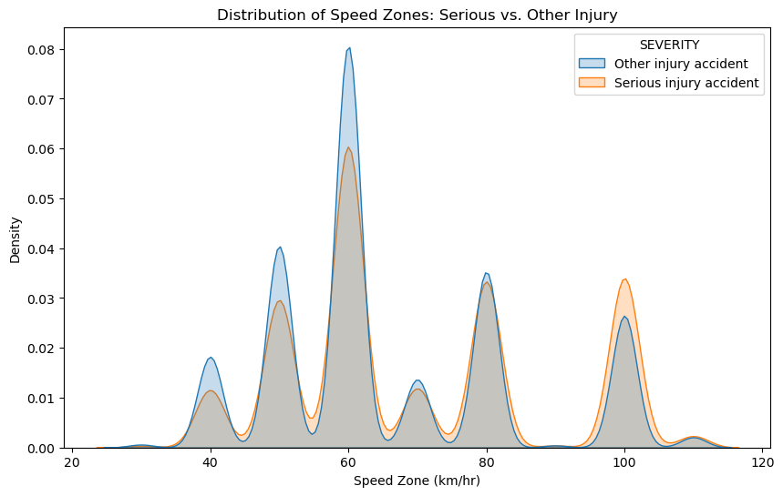
A Bar chart was also used to show the major question of if higher speed zones lead to more victims per accident. np.mean was used as the estimator while using seaborn’s bar plot. It answers that higher speed zones do correlate with more victims per accidents and is consistent with the known relationship between vehicle speed and crash severity.
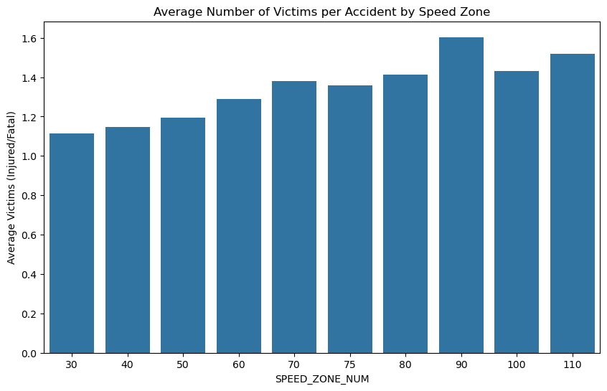

Q3
The top 5 LGAS by accident count reflect high-traffic urban areas. The speed zone boxplots were the most ideal graph to use as it shows the median, IQR and outliers in parallel. This reveals the difference in road infrastructure while some LGAs have a mix of suburban and arterial roads while others cluster around lower speed limits in urban areas. The severity breakdown was visualized by a stacked bar chart with the LGAs grouped by different accident counts. The chart shows that despite having higher accident volumes, many of the LGAs maintain a lower proportion of serious and fatal crashes, this could be possible due to the lower speed environments and better roads. LGAs with higher speed zones tend to have more accidents that are serious or fatal. This is consistent with the relationship between vehicle speed and crash severity.
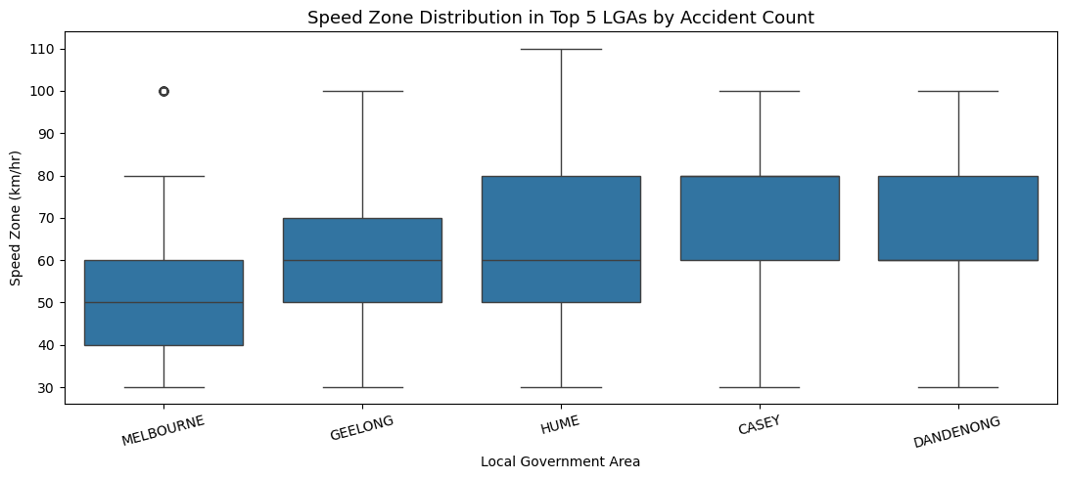

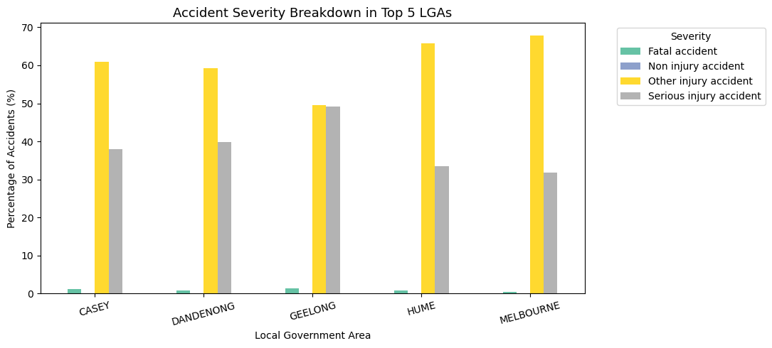

References:
The pandas development team. (2024). pandas documentation. https://pandas.pydata.org/docs/
Harris, C. R., Millman, K. J., van der Walt, S. J., et al. (2020). Array programming with NumPy. Nature, 585, 357–362. https://doi.org/10.1038/s41586-020-2649-2
Hunter, J. D. (2007). Matplotlib: A 2D graphics environment. Computing in Science & Engineering, 9(3), 90–95. https://doi.org/10.1109/MCSE.2007.55
Waskom, M. L. (2021). seaborn: Statistical data visualization. Journal of Open Source Software, 6(60), 3021. https://doi.org/10.21105/joss.03021
Victorian road crash data

